Announcements
On our calendar – Ladies Aid, November 4th @ 12:30pm
Community Dinner, November 11th @ 4:30pm
Advent Book Study, November 29th @ 9am
Hanging of the Greens, November 29th
November Birthdays: Linda Degner – Nov. 15th, Betty Pinkston – Nov. 18th, Angie Myers – Nov. 20th

November Anniversary: Leroy and Sharon White – Nov. 20th

Pastor Joel Zimmerman can be reached at 715-416-8992 and pastorjzimmerman@gmail.com.

In our prayers: Margie, the people of Ukraine, Stacy Hall, Kip, all innocent lives caught in the line of fire, those battling cancer, Janice, Sharon White, Barb’s sister’s friend, Karen, Judy’s Grandson, Beverly Burrill, Betty Thake’s daughter, world peace. Betty’s daughter, Brenda. Mary’s Daughter-in law, those affected by war and insecurity, Barb’s friend’s son- Jim, Angie’s mom, Kathy’s family, Nancy’s cousin Betty, Betty Thake,

🕊️ Prayer of the Week
God of grace, help me recognize the difference between being noticed and making a difference. Give me the humility to listen, the courage to serve, and the wisdom to remember that every person I meet is worthy of dignity and love. Amen.

Namekagon Congregational Church, UCC
W4446 Friday Street
Earl, WI 54875 • 715-635-2903
www.earlucc.com

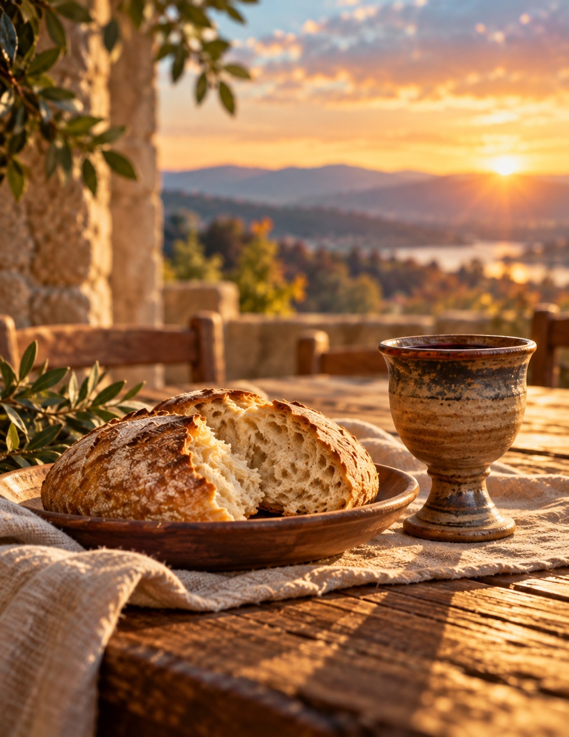

November 1st, 2026
10:30 am Worship

*Please rise if you are able at these points in the service
Gathering Music
Welcome, Church Announcements and Special Concerns
Prelude and Time of Quiet Reflection
*Call to Worship
One: We gather not because we have earned a place of honor, but because God's love has made room for us.
All: We come as we are, welcomed by grace.
One: We gather not to prove our importance, but to discover the joy of serving one another.
All: We come ready to learn, to love, and to grow.
One: At God's table, no one is greater and no one is forgotten.
All: We are one family, united in Christ.
One: Come, let us worship the God who lifts up the humble and calls us to lives of compassion.
All: With grateful hearts, we come to worship!

*Hymn “Great is Thy Faithfulness” No. 86

Opening Prayer (Unison)
Gracious God, we enter this place carrying our accomplishments, our worries, our opinions, and sometimes our pride. Help us set aside the need to impress and open our hearts to your presence. Teach us to listen more carefully, love more generously, and serve more willingly. Remind us that our worth is not measured by the attention we receive, but by the love you have already given us. May our worship today make us more faithful in the ordinary moments of life. Amen.

Scripture Reading Matthew 23:1-12

Hymn “Spirit of the Living God” Twice No. 259

Message

Hymn “Amazing Grace" No. 546

Prayers of the People
Silent Prayer
Pastoral Prayer and The Lord's Prayer
Our Father, who art in heaven, hallowed be Thy Name. Thy kingdom come, thy will be done on earth as it is in heaven. Give us this day our
daily bread. And forgive us our sins, as we forgive those who sin
against us. And lead us not into temptation, but deliver us from evil.
For thine is the kingdom and the power, and the glory, forever and ever. Amen.

Offering Invitation

*Response No.46
Praise God from whom all blessings flow; praise God, all creatures
here below; praise God above, ye heavenly host: Praise God, the Son,
and Holy Ghost. Amen.

*Prayer of Dedication (Unison)
Bless these gifts by the power of your Spirit, O God. May
someone near or far receive grace and hope for living because of
what we share here today. Amen.

Holy Communion See Insert

*Hymn “Lord, Whose Love in Humble Service” No. 461

*Benediction
Go into the world knowing that you are loved, that your life matters, and that greatness is found in serving others. May your words bring kindness, your actions bring hope, and your presence make someone's burden lighter. Go in peace, and go with God. Amen.
*Closing "Go in Peace"
Go in peace and the peace of God be with you this day,
Go in peace and the peace of God be with you always.
Celebrate and share the joy, Celebrate new life,
Go in peace and the peace of God be with you always.
*Postlude

Holy Communion

Beloved in Christ,
The Gospel tells us that on the first day of the week
Jesus Christ was raised from death, appeared to Mary Magdalene,
On that same day he sat at the table with two disciples, and was made known to them in the breaking of the bread.
This is the joyful feast of the people of God.
Men and women, youth and children, come from the east and the west, from the north and the south, and gather about Christ’s table.
This table is for all Christians who wish to know the presence of Christ and to share in the community of God’s people.

God be with you
And also with you.
Lift up your hearts.
We lift them to God.
Let us give thanks to God Most High.
It is right to give God thanks and praise.
…
And so,
with all your people on earth
in every place where two or more are gathered in your name
and all the company of heaven who have gone before us
we praise your name and join their unending hymn:
Holy, holy, holy Lord, God of power and might,
heaven and earth are full of your glory.
Hosanna in the highest.
Blessed is the one who comes in the name of the Lord.
Hosanna in the highest.
…
And so,
in remembrance of these your mighty acts in Jesus Christ
we offer ourselves in praise and thanksgiving
as a holy and living sacrifice,

in union with Christ's offering for us
as we proclaim the mystery of faith.
Christ has died; Christ is risen; Christ will come again.

…

Let us pray,
Almighty God,
We give you thanks for the gift of our Savior’s presence in the simplicity and splendor of this holy meal. Unite us with all who are fed by Christ’s body and blood that we may faithfully proclaim the good news of your love and that your universal church may be a rainbow of hope in an uncertain world; through Jesus Christ our Redeemer. Amen

Holy Communion

Beloved in Christ,
The Gospel tells us that on the first day of the week
Jesus Christ was raised from death, appeared to Mary Magdalene,
On that same day he sat at the table with two disciples, and was made known to them in the breaking of the bread.
This is the joyful feast of the people of God.
Men and women, youth and children, come from the east and the west, from the north and the south, and gather about Christ’s table.
This table is for all Christians who wish to know the presence of Christ and to share in the community of God’s people.

God be with you
And also with you.
Lift up your hearts.
We lift them to God.
Let us give thanks to God Most High.
It is right to give God thanks and praise.
…
And so,
with all your people on earth
in every place where two or more are gathered in your name
and all the company of heaven who have gone before us
we praise your name and join their unending hymn:
Holy, holy, holy Lord, God of power and might,
heaven and earth are full of your glory.
Hosanna in the highest.
Blessed is the one who comes in the name of the Lord.
Hosanna in the highest.
…
And so,
in remembrance of these your mighty acts in Jesus Christ
we offer ourselves in praise and thanksgiving
as a holy and living sacrifice,

in union with Christ's offering for us
as we proclaim the mystery of faith.
Christ has died; Christ is risen; Christ will come again.

…

Let us pray,
Almighty God,
We give you thanks for the gift of our Savior’s presence in the simplicity and splendor of this holy meal. Unite us with all who are fed by Christ’s body and blood that we may faithfully proclaim the good news of your love and that your universal church may be a rainbow of hope in an uncertain world; through Jesus Christ our Redeemer. Amen

