Announcements
On our calendar – Call Committee – October 18th
Deacon’s Meeting – October 25th
Quarterly Meeting – October 25th
October Birthdays: Kimberly Crouse – October 5th, Betty Thake – October 6, Charlotte Thompson – October 18, Isaiah Mork – October 26

Pastor Joel Zimmerman can be reached at 715-416-8992 and pastorjzimmerman@gmail.com.

In our prayers: Margie, the people of Ukraine, Stacy Hall, Kip, all innocent lives caught in the line of fire, those battling cancer, Janice, Sharon White, Barb’s sister’s friend, Karen, Judy’s Grandson, Beverly Burrill, Betty Thake’s daughter, world peace. Betty’s daughter, Brenda. Mary’s Daughter-in law, those affected by war and insecurity, Barb’s friend’s son- Jim, Angie’s mom, Kathy’s family, Nancy’s cousin Betty, Betty Thake,

🕊️ Prayer of the Week
Gracious God, in a world filled with distractions and demands, help us recognize your invitations to love, serve, and celebrate. Teach us to treasure the moments that matter, embrace opportunities for kindness, and make room for joy in our everyday lives. May we never become so busy that we miss the beauty of the life you have given us. Amen.

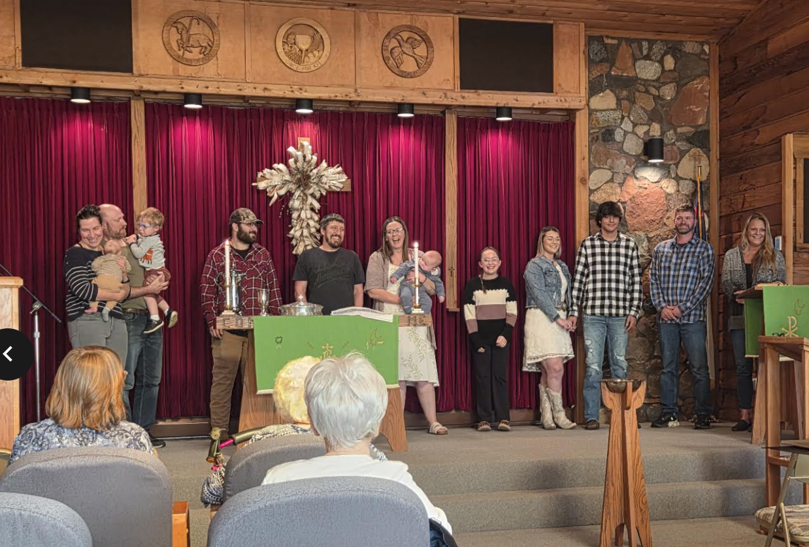
Namekagon Congregational Church, UCC
W4446 Friday Street
Earl, WI 54875 • 715-635-2903
www.earlucc.com

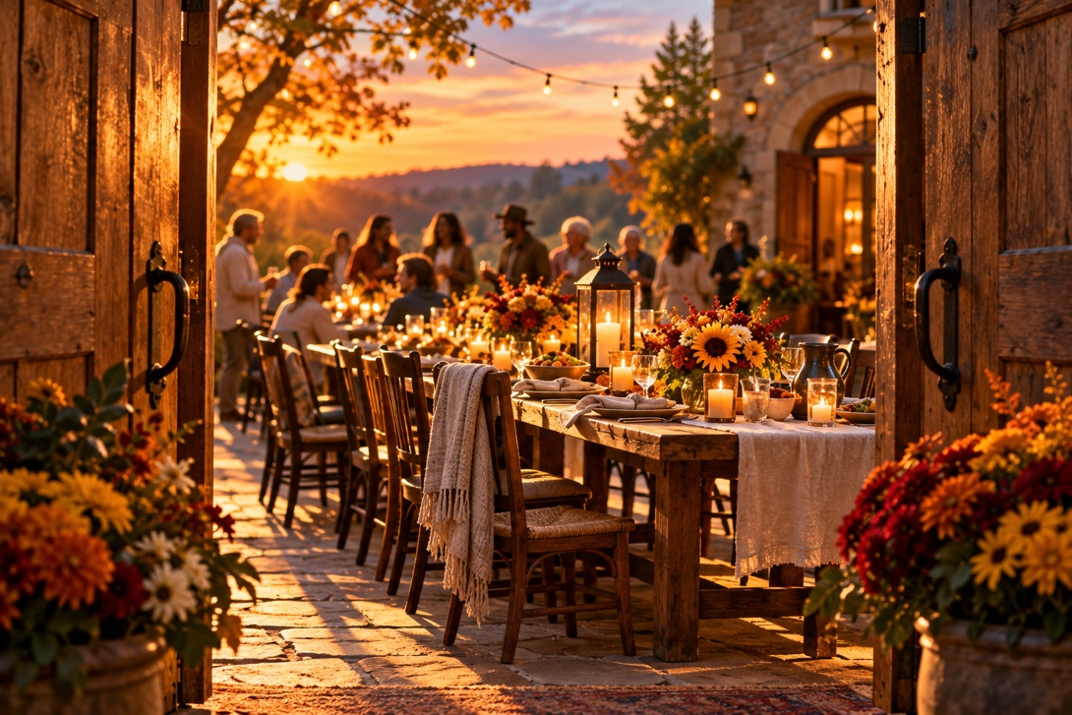

October 11th, 2026
10:30 am Worship

*Please rise if you are able at these points in the service
Gathering Music
Welcome, Church Announcements and Special Concerns
Prelude and Time of Quiet Reflection
*Call to Worship
One: God has prepared a celebration, and the invitation has been sent!
All: We come with open hearts, ready to receive the gifts of God's grace.
One: Too often, we allow the busyness of life to distract us from what truly matters.
All: Today, we set aside our distractions and make room for God's presence.
One: We are invited to experience joy, practice compassion, and discover the abundance of God's love.
All: May we recognize the blessings before us and share them generously with others.
One: The table is prepared, the invitation is ours, and the celebration is waiting!
All: Let us worship God with grateful hearts and joyful spirits!

*Hymn “How Great Thou Art” No. 33

Opening Prayer (Unison)
Gracious and loving God, in the busyness of our lives, we sometimes forget to notice the beauty, joy, and opportunities you place before us. We become distracted by our responsibilities, overwhelmed by our worries, and so focused on tomorrow that we forget to appreciate today. As we gather in worship, quiet our restless minds and open our hearts to your presence. Remind us that faith is not simply another obligation, but an invitation to experience life more fully through love, generosity, and grace. Help us recognize the moments that truly matter and give us the courage to respond when you call. Amen.

Scripture Reading Matthew 22:1-14

Hymn “Spirit of the Living God” Twice No. 259

Message

Hymn “Hope of the World" No. 538

Prayers of the People
Silent Prayer
Pastoral Prayer and The Lord's Prayer
Our Father, who art in heaven, hallowed be Thy Name. Thy kingdom come, thy will be done on earth as it is in heaven. Give us this day our
daily bread. And forgive us our sins, as we forgive those who sin
against us. And lead us not into temptation, but deliver us from evil.
For thine is the kingdom and the power, and the glory, forever and ever. Amen.

Offering Invitation

*Response No.46
Praise God from whom all blessings flow; praise God, all creatures
here below; praise God above, ye heavenly host: Praise God, the Son,
and Holy Ghost. Amen.

*Prayer of Dedication (Unison)
Bless these gifts by the power of your Spirit, O God. May
someone near or far receive grace and hope for living because of
what we share here today. Amen.

*Hymn “Precious Lord, Take My Hand” No. 628

*Benediction
Go into the world with open hearts and attentive spirits. Don't let the busyness of life steal the joy of living. Love generously, celebrate often, and recognize God's presence in the moments that matter most. The invitation is yours. Go in peace, and live it fully. Amen.
*Closing "Go in Peace"
Go in peace and the peace of God be with you this day,
Go in peace and the peace of God be with you always.
Celebrate and share the joy, Celebrate new life,
Go in peace and the peace of God be with you always.
*Postlude

