Announcements
On our calendar – Deacon’s Meeting – September 27th @ 9:30am
Church Fundraiser – October 10th
September Birthdays: Leroy White – September 6, Rich Humphrey – September 11, Kathy Bartilson – September 24

September Anniversaries: Melissa and Matthew Ray – September 13th

Pastor Joel Zimmerman can be reached at 715-416-8992 and pastorjzimmerman@gmail.com.

In our prayers: Margie, the people of Ukraine, Stacy Hall, Kip, all innocent lives caught in the line of fire, those battling cancer, Janice, Sharon White, Barb’s sister’s friend, Karen, Judy’s Grandson, Beverly Burrill, Betty Thake’s daughter, world peace. Betty’s daughter, Brenda. Mary’s Daughter-in law, those affected by war and insecurity, Barb’s friend’s son- Jim, Angie’s mom, Kathy’s family, Nancy’s cousin Betty.

🕊️ Prayer of the Week
God of abundance, when fear tells us there is not enough, remind us of your grace. Help us notice those who are overlooked, seek peace through justice, and trust you through every season of change. Amen.

Namekagon Congregational Church, UCC
W4446 Friday Street
Earl, WI 54875 • 715-635-2903
www.earlucc.com

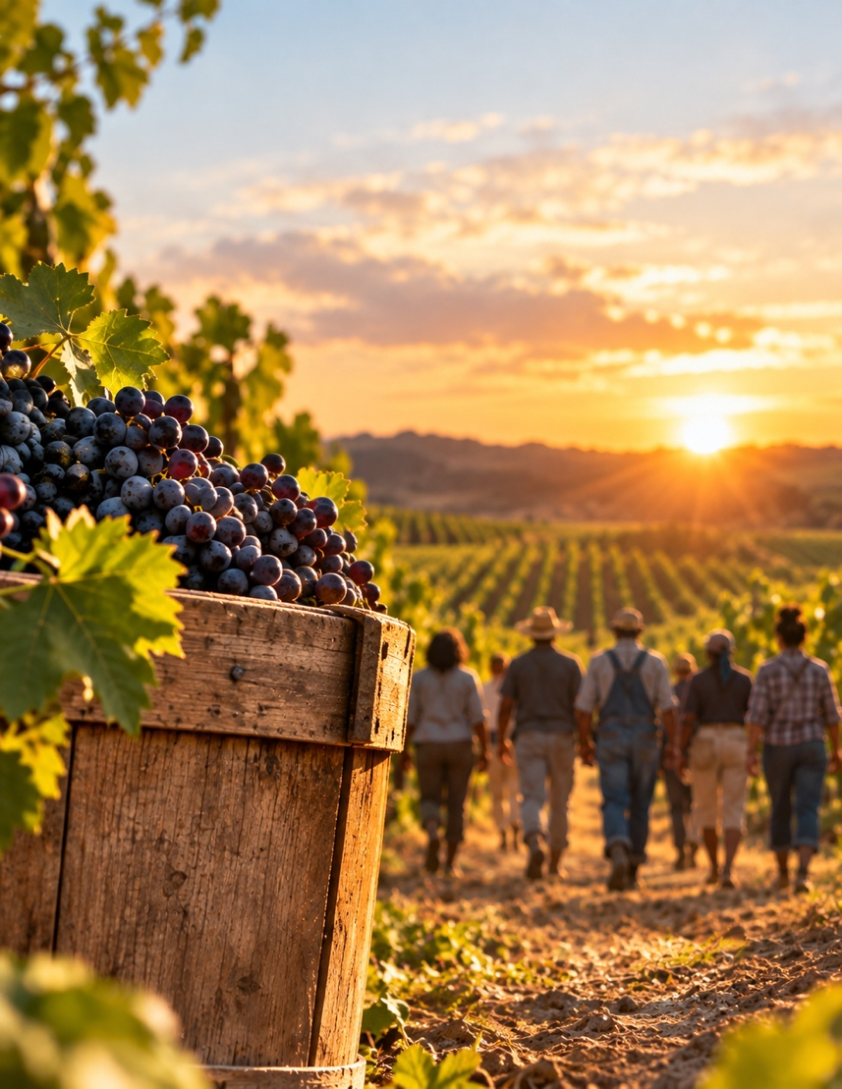

September 20th, 2026
10:30 am Worship

*Please rise if you are able at these points in the service
Gathering Music
Welcome, Church Announcements and Special Concerns
Prelude and Time of Quiet Reflection

*Call to Worship
One: God calls us from the morning and from the afternoon, from familiar places and unexpected ones.
All: There is room for us in God's vineyard.
One: God sees those who have been overlooked and welcomes those who have been left waiting.
All: There is enough grace for everyone.
One: God calls us to seek peace rooted in justice, dignity, compassion, and love.
All: There is enough hope to build a better world.
One: Come, people of God. The work of love continues.
All: We come to worship, to serve, and to trust the God who is not finished with us.

*Hymn “Sing Praise to God Who Reigns Above!” No. 6

Opening Prayer (Unison)
Generous God, you meet us in every season and call us again into the work of your love. Free us from the fear that there is not enough. Teach us to see those who are overlooked, to seek justice that leads to peace, and to trust you when the future is not yet clear. Open our hearts to your abundant grace and make us courageous workers in your vineyard. Amen.

Scripture Reading Matthew 20:1-16

Hymn “Spirit of the Living God” Twice No. 259

Message

Hymn “Jesus, Lover of My Soul" No. 542

Prayers of the People
Silent Prayer
Pastoral Prayer and The Lord's Prayer
Our Father, who art in heaven, hallowed be Thy Name. Thy kingdom come, thy will be done on earth as it is in heaven. Give us this day our
daily bread. And forgive us our sins, as we forgive those who sin
against us. And lead us not into temptation, but deliver us from evil.
For thine is the kingdom and the power, and the glory, forever and ever. Amen.

Offering Invitation

*Response No.46
Praise God from whom all blessings flow; praise God, all creatures
here below; praise God above, ye heavenly host: Praise God, the Son,
and Holy Ghost. Amen.

*Prayer of Dedication (Unison)
Bless these gifts by the power of your Spirit, O God. May
someone near or far receive grace and hope for living because of
what we share here today. Amen.

*Hymn “Lord, Whose Love Through Humble Service. No. 461

*Benediction
Go into the world trusting that God's grace is enough.
Make room for the overlooked.
Seek justice.
Practice peace.
Love generously.
And whatever tomorrow brings, remember:
God is still in the vineyard.
Amen.

*Closing "Go in Peace"
Go in peace and the peace of God be with you this day,
Go in peace and the peace of God be with you always.
Celebrate and share the joy, Celebrate new life,
Go in peace and the peace of God be with you always.
*Postlude

