***Announcements***

**On our calendar –** **May 7th: Ladies Aid**

**May 14th: Community Meal**

**May Birthdays:** Duane Peterson – May 5th, Therese Canfield – May 25th,

**Pastor Joel Zimmerman** can be reached at ***715-416-8992*** and [pastorjzimmerman@gmail.com](mailto:pastorjzimmerman@gmail.com).

**In our prayers:**  Margie, Tammy, Therese Canfield, the people of Ukraine, Stacy Hall, Kip, Barb’s friends Rita and Chuck, the Ray Family, the people of Israel, Gaza, and all innocent lives caught in the line of fire, those battling cancer, Janice, Lee White, families mourning loss due to gun violence, those harmed by recent hurricanes, floods, and disasters, Desmond, Barb’s sister’s friend, Karen, Charlotte’s sister, Californians, Baby Thomas, Judy’s newest Grandson, Alyssa Degner, Beverly Burrill, Lorie and her family, Nancy, Kimmy

**Prayer of the Week:**

Heavenly Father, Thank you for the gift of a new week. I am grateful for the opportunities ahead and the blessings you have in store. Fill my heart with joy, my mind with peace, and my spirit with energy to embrace each day. Amen

**Namekagon Congregational Church, UCC**

W4446 Friday Street

Earl, WI 54875 • 715-635-2903

[www.earlucc.com](http://www.earlucc.com)

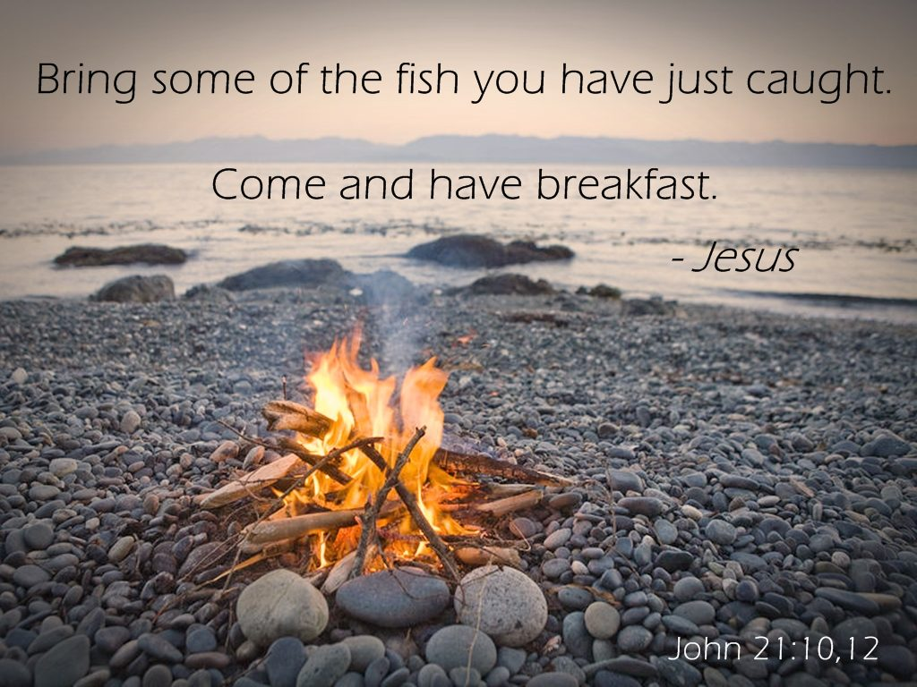

**May 4th, 2025**

**10:30 am Worship**

*\*Please rise if you are able at these points in the service*

**Gathering Music**

**Welcome, Church Announcements and Special Concerns**

**Prelude and Time of Quiet Reflection**

**\*Call to Worship**

L: Christ asked Peter if he loved him.  
**P: Peter affirmed three times his love of the Lord.**L: Christ asks us if we love him.  
**P: We affirm our love of the Lord in our worship**L: Christ calls us to demonstrate our love in service.  
**P: Lord, help us to witness to your love in the ways in which we care for others. AMEN**

**\*Hymn** "Come Christians, Join to Sing" **No. 90**

**Opening Prayer** (*Unison*)

**God of power and might, let your love shine on us and through us to others. Take the blindness from our eyes and our hearts. Give us the joy of knowing and serving you in all that we say, think and do. In Jesus’ Name, we pray. Amen.**

**Scripture Reading**  John 21:1-19

**Hymn** “Spirit of the Living God” *Twice*  **No. 259**

**Message**

**Hymn** “O How I Love Jesus" **No. 99**

**Prayers of the People**

**Silent Prayer**

**Pastoral Prayer and The Lord's Prayer**

**Our Father, who art in heaven, hallowed be Thy Name. Thy kingdom come, thy will be done on earth as it is in heaven. Give us this day our**

**daily bread. And forgive us our sins, as we forgive those who sin**

**against us. And lead us not into temptation, but deliver us from evil.**

**For thine is the kingdom and the power, and the glory, forever and**

**ever. Amen.**

**Offering Invitation**

**\*Response No.46**

**Praise God from whom all blessings flow; praise God, all creatures here below; praise God above, ye heavenly host: Praise God, the Son, and Holy Ghost. Amen.**

**\*Prayer of Dedication** (*Unison*)   
**Bless these gifts by the power of your Spirit, O God. May someone near or far receive grace and hope for living**

**because of what we share here today. Amen.**

**Holy Communion** See insert

**\*Hymn** “Jesu, Jesu” **No. 600**

**\*Benediction**

You are people of the Resurrection! You know the powerful love of God! Go into God’s world proclaiming hope, peace, and joy, in the name of the Risen Lord. **AMEN.**

**\*Closing**  "Go in Peace"

**Go in peace and the peace of God be with you this day,**

**Go in peace and the peace of God be with you always.**

**Celebrate and share the joy, Celebrate new life,**

**Go in peace and the peace of God be with you always.**

**\*Postlude**

**Holy Communion**

Beloved in Christ,

The Gospel tells us that on the first day of the week

Jesus Christ was raised from death, appeared to Mary Magdalene,

On that same day he sat at the table with two disciples, and was made known to them in the breaking of the bread.

**This is the joyful feast of the people of God.**

**Men and women, youth and children, come from the east and the west, from the north and the south, and gather about Christ’s table.**

This table is for all Christians who wish to know the presence of Christ and to share in the community of God’s people.

God be with you

**And also with you.**

Lift up your hearts.

**We lift them to God.**

Let us give thanks to God Most High.

**It is right to give God thanks and praise.**

…

And so,  
with all your people on earth  
in every place where two or more are gathered in your name  
and all the company of heaven who have gone before us  
we praise your name and join their unending hymn:

**Holy, holy, holy Lord, God of power and might,  
heaven and earth are full of your glory.  
Hosanna in the highest.  
Blessed is the one who comes in the name of the Lord.  
Hosanna in the highest.**

…

And so,  
in remembrance of these your mighty acts in Jesus Christ  
we offer ourselves in praise and thanksgiving  
as a holy and living sacrifice,

in union with Christ's offering for us  
as we proclaim the mystery of faith.

**Christ has died; Christ is risen; Christ will come again.**

**…**

Let us pray,

**Almighty God,**

**We give you thanks for the gift of our Savior’s presence in the simplicity and splendor of this holy meal. Unite us with all who are fed by Christ’s body and blood that we may faithfully proclaim the good news of your love and that your universal church may be a rainbow of hope in an uncertain world; through Jesus Christ our Redeemer. Amen**

**Holy Communion**

Beloved in Christ,

The Gospel tells us that on the first day of the week

Jesus Christ was raised from death, appeared to Mary Magdalene,

On that same day he sat at the table with two disciples, and was made known to them in the breaking of the bread.

**This is the joyful feast of the people of God.**

**Men and women, youth and children, come from the east and the west, from the north and the south, and gather about Christ’s table.**

This table is for all Christians who wish to know the presence of Christ and to share in the community of God’s people.

God be with you

**And also with you.**

Lift up your hearts.

**We lift them to God.**

Let us give thanks to God Most High.

**It is right to give God thanks and praise.**

…

And so,  
with all your people on earth  
in every place where two or more are gathered in your name  
and all the company of heaven who have gone before us  
we praise your name and join their unending hymn:

**Holy, holy, holy Lord, God of power and might,  
heaven and earth are full of your glory.  
Hosanna in the highest.  
Blessed is the one who comes in the name of the Lord.  
Hosanna in the highest.**

…

And so,  
in remembrance of these your mighty acts in Jesus Christ  
we offer ourselves in praise and thanksgiving  
as a holy and living sacrifice,

in union with Christ's offering for us  
as we proclaim the mystery of faith.

**Christ has died; Christ is risen; Christ will come again.**

**…**

Let us pray,

**Almighty God,**

**We give you thanks for the gift of our Savior’s presence in the simplicity and splendor of this holy meal. Unite us with all who are fed by Christ’s body and blood that we may faithfully proclaim the good news of your love and that your universal church may be a rainbow of hope in an uncertain world; through Jesus Christ our Redeemer. Amen**