***Announcements***

**In our calendar – January 19th,** Budget Meeting

**January 26th,** Deacon’s Meeting, Annual Meeting

**January Birthdays:** John Canfield, January 7th, Matthew Ray– January 13th, Dakota Mork – January 25th

**In our prayers:**  Margie, Tammy, Lee, Glen, Therese Canfield, Toni, Betty, the people of Ukraine, Bruce, Mary’s neighbors, Becca Oden, Tracey Peterson, Stacy Hall, Vicky, Judy, Philip, Kip, Barb’s friends Rita and Chuck, Barb’s friend’s grandson Noah, the Ray Family, Kris Albert, the people of Israel, Gaza, and all innocent lives caught in the line of fire, those battling cancer, Janice, Kathy’s mother and family, Doug, Lisa, Lee White, families mourning loss due to gun violence, those harmed by recent hurricanes, floods, and disasters, Desmond, Greg’s Brother, Barb’s. sister’s friend, Karen, Bonnie’s Son-in-law Steve, Charlotte’s sister, Californians, Baby Thomas, Judy’s newest Grandson

**Prayer of the Week:**

Gracious God, we live in the tension between expectation and reality. Sometimes, we navigate that tension with hope and clarity. At other times, we fester in doubt, disappointment, and uncertainty. Help us to release our need to control and enable us to embrace the possibilities. May our trust in your goodness and the power you have poured into us embolden our faith. Amen.

**Namekagon Congregational Church, UCC**

W4446 Friday Street

Earl, WI 54875 • 715-635-2903

[www.earlucc.com](http://www.earlucc.com)

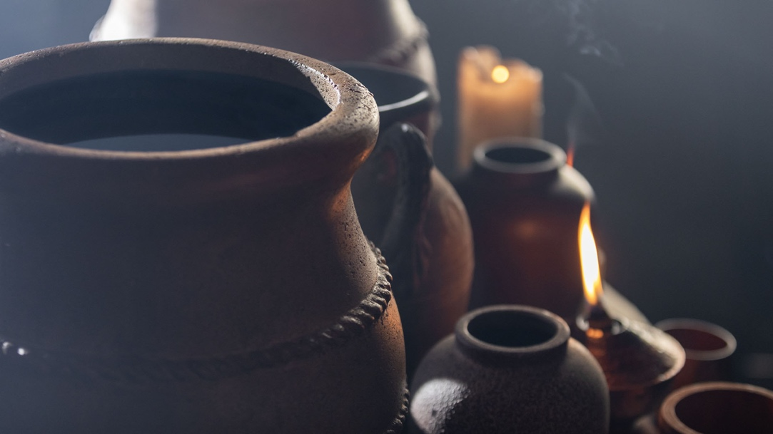

**January 19th, 2025**

**10:30 am Worship**

*\*Please rise if you are able at these points in the service*

**Gathering Music**

**Welcome, Church Announcements and Special Concerns**

**Prelude and Time of Quiet Reflection**

**\*Call to Worship**

L: How can we keep still this day?

**P: There is joy in this place!**

L: God's steadfast love extends to everyone.

**P: God reaches out to us all in forgiveness and compassion.**

L: Thanks to God for all the wonderful blessings we have received.

**P: Let us celebrate God's joyful love for and with us! AMEN.**

**\*Hymn** "All Hail the Power of Jesus’ Name" **No. 91**

**Opening Prayer** (*Unison*)

**Lord, open our hearts to the surprising ways in which you offer to us your love and your presence. Help us to truly believe in the wondrous ways that you work in our lives. Give us hearts and spirits for service to you. In Jesus' Name, we pray. AMEN.**

**Scripture Reading**  John 2:1-11

**Hymn** “Spirit of the Living God” *Twice*  **No. 259**

**Message**

**Hymn** “For the Beauty of the Earth" **No. 56**

**Prayers of the People**

**Silent Prayer**

**Pastoral Prayer and The Lord's Prayer**

**Our Father, who art in heaven, hallowed be Thy Name. Thy kingdom come, thy will be done on earth as it is in heaven. Give us this day our**

**daily bread. And forgive us our sins, as we forgive those who sin**

**against us. And lead us not into temptation, but deliver us from evil.**

**For thine is the kingdom and the power, and the glory, forever and ever. Amen.**

**Offering Invitation**

**\*Response No.46**

**Praise God from whom all blessings flow; praise God, all creatures here below; praise God above, ye heavenly host: Praise God, the Son, and Holy Ghost. Amen.**

**\*Prayer of Dedication** (*Unison*)   
**Bless these gifts by the power of your Spirit, O God. May someone near or far receive grace and hope for living because**

**of what we share here today. Amen.**

**\*Hymn** “Take My Life and Let it be Consecrated” **No. 609**

**\*Benediction**

May you be filled by the presence of God  
May you draw from the wells of justice, peace, and righteousness  
May you taste the fruit of the Spirit  
As you make the way of Jesus your path in the world  
And you make the name of God known in word and deed.  
Go, in peace and power to love and serve God and neighbor. **Amen.**

**\*Closing**  "Go in Peace"

**Go in peace and the peace of God be with you this day,**

**Go in peace and the peace of God be with you always.**

**Celebrate and share the joy, Celebrate new life,**

**Go in peace and the peace of God be with you always.**

**\*Postlude**