***Announcements***

**On our calendar – December 24**th, Christmas Eve Service 2pm  
 December 25*th,* Christmas Day (No Service)

**December Birthdays:** Melissa Ray, December 3rd, Steve Hammerel- December 4th, Carol Buckman– December 6th, Kevin Hagen – December 19th, Nancy Benevides – December 30th

**December Anniversaries:** Steve and Deb Hammerel – December 18th Kevin Hagen and Kathy Bartilson – December 23rd

**In our prayers:**  Margie, Tammy, Lee, Glen, Therese Canfield, Toni, Betty, the people of Ukraine, Bruce, Mary’s neighbors, Becca Oden, Tracey Peterson, Stacy Hall, Vicky, Judy, Philip, Kip, Barb’s friends Rita and Chuck, Barb’s friend’s grandson Noah, the Ray Family, Kris Albert, the people of Israel, Gaza, and all innocent lives caught in the line of fire, those battling cancer, Janice, Kathy’s mother and family, Doug, Lisa, Lee White, families mourning loss due to gun violence, those harmed by recent hurricanes, floods, and disasters, Desmond, Greg’s Brother, Barb’s. sister’s friend, Karen, Bonnie’s Son-in-law Steve,

**Namekagon Congregational Church, UCC**

W4446 Friday Street

Earl, WI 54875 • 715-635-2903

[www.earlucc.com](http://www.earlucc.com)

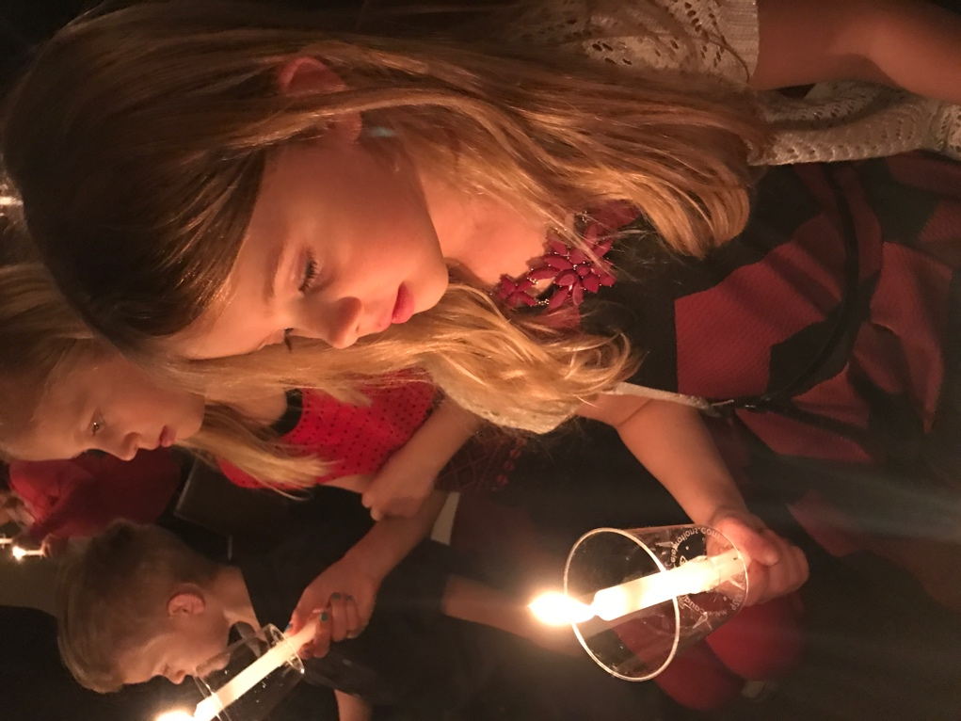

**Christmas Eve**

**December 24, 2024**

**10:30 am Worship**

*\*Please rise if you are able at these points in the service*

**Ringing of the Bells**

**Welcome**

**Prelude and Time of Quiet Reflection**

**\*Call to Worship**

The people who walked in deep shadows have seen a great light.

**Those who lived in deep shadows, on them light has shined.**

Let us sing a new song.

**Let the seas thunder! Let the trees shout for joy.**

Breathe deep of the starlight, the animals, the child.

**Let us ponder all these things in our heart.**

Glory to God, and peace on earth!

**For Jesus Christ is born!**

**\*Hymn** "O Come All Ye Faithful" **No. 148**

**Lighting of the Christ Candle**

**Scripture Reading**   Isaiah 9:2-7

**\*Hymn** “O Little Town of Bethlehem”  **No. 144**

**Scripture Reading**  Titus 2:11-14

**\*Hymn** “The First Noel”  **No. 151**

**Gospel Reading**  John 1:9-14

**\*Hymn** “Joy to the World”  **No. 143**

**The Lord's Prayer**

**Our Father, who art in heaven, hallowed be Thy Name. Thy kingdom come, thy will be done on earth as it is in heaven. Give us this day our**

**daily bread. And forgive us our sins, as we forgive those who sin**

**against us. And lead us not into temptation, but deliver us from evil.**

**For thine is the kingdom and the power, and the glory, forever and**

**ever. Amen.**

**Offering Invitation and Offering**

**\*Response**

**Angels we have heard on high Sweetly singing o’er the plains, And the mountains in reply Echo back their joyous strains. Gloria in excelsis Deo, Gloria in excelsis Deo.**

**\*Prayer of Dedication** (*Unison*)

**Loving God, we give thanks for the visions and dreams**

**that you share with your people.** **We offer these gifts in response to your abundant blessings** **and ask that you use them and the commitment they represent** **to share your good news with all the world. Amen.**

**\*Hymn** “Go, Tell It on the Mountain” **No. 167**

**Christmas Message**

**Passing of Light** “Silent Night”  **No. 145**

**\*Benediction**

Place your trust in God, for God is with you. Listen carefully for God’s loving whisper in this time--the words will give you healing and hope. Go in peace and may God’s peace always be with you. **AMEN.**

*\*\*\*The photo on the front of the bulletin is from Christmas Eve, 2016. Ainsley was so focused and awed by the light of the candle during the singing of Silent Night, Holy Night that I had to capture that image to share for years to come. May we all be in as much awe and wonderment this Christmas season.*