***Announcements***

**On our calendar – December 22nd, Advent Study 9am**

**Christmas Fund Special Offering**

**December 24**th, Christmas Eve Service 2pm  
 December 25*th,* Christmas Day (No Service)

**December Birthdays:** Melissa Ray, December 3rd, Steve Hammerel- December 4th, Carol Buckman– December 6th, Kevin Hagen – December 19th, Nancy Benevides – December 30th

**December Anniversaries:** Steve and Deb Hammerel – December 18th Kevin Hagen and Kathy Bartilson – December 23rd

**In our prayers:**  Margie, Tammy, Lee, Glen, Therese Canfield, Toni, Betty, the people of Ukraine, Bruce, Mary’s neighbors, Becca Oden, Tracey Peterson, Stacy Hall, Vicky, Judy, Philip, Kip, Barb’s friends Rita and Chuck, Barb’s friend’s grandson Noah, the Ray Family, Kris Albert, the people of Israel, Gaza, and all innocent lives caught in the line of fire, those battling cancer, Janice, Kathy’s mother and family, Doug, Lisa, Lee White, families mourning loss due to gun violence, those harmed by recent hurricanes, floods, and disasters, Desmond, Greg’s Brother, Barb’s. sister’s friend, Karen, Bonnie’s Son-in-law Steve, Kathy’s mom who turns 98 today

**Prayer of the Week:**

*Father, thank You for this gift that is unlike any other gift that has ever been given. Thank You for sending Your Son. We forget what a wonderful and amazing gift our salvation really is. Fill us with your hope and joy—a joy so complete and overwhelming that we, like the shepherds, are compelled to share it with others. We are thankful for the certainty of heaven in Jesus. But until that day, we, like the shepherds, will choose to glorify and praise You. We will continue to rejoice in who You are and all that You’ve done. We thank You and praise You. And it is in Jesus’s name that we pray, amen.*

**Namekagon Congregational Church, UCC**

W4446 Friday Street

Earl, WI 54875 • 715-635-2903

[www.earlucc.com](http://www.earlucc.com)

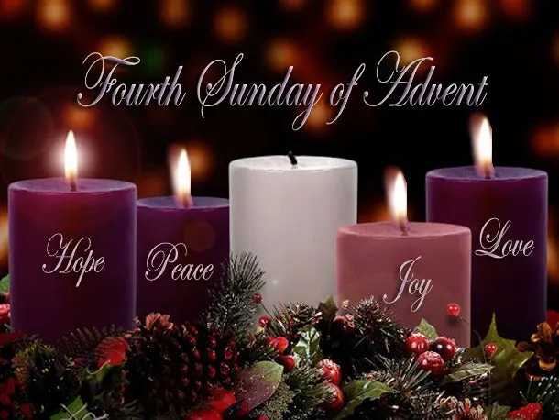

**December 22nd, 2024**

**10:30 am Worship**

*\*Please rise if you are able at these points in the service*

**Gathering Music**

**Welcome, Church Announcements and Special Concerns**

**Lighting of the Advent Candle**

**Prelude and Time of Quiet Reflection**

**\*Call to Worship**

L: All through this season of Advent, we have encountered Hope, Peace and Joy.  
**P: Today Belief and Love are the theme.**L: Today we will hear the story of surprising commitment.  
**P: We will learn of Mary and God's wonderful love.**L: Today we will be challenged to believe in all that God can do.  
**P: Open our hearts, Lord, that we may be ready for your love. AMEN.**

**\*Hymn** "One Candle Is Lit” **vs. 1-4 No. 128**

**Opening Prayer** (*Unison*)

**Lord, be with us this morning as we encounter Mary and hear of the wondrous news that she received. Remind us that, like Mary, each one of us is a bearer of your Good News. We are called to proclaim hope, peace, joy, and love in your name. Open our hearts and our spirits today to receive with great joy the love that you have for us. For we ask this in Jesus' Name. AMEN.**

**Scripture Reading**  Luke 1:46-55

**Hymn** “Spirit of the Living God” *Twice*  **No. 259**

**Message**

**Hymn** “Come, O Long-expected Jesus" **No. 125**

**Prayers of the People**

**Silent Prayer**

**Pastoral Prayer and The Lord's Prayer**

**Our Father, who art in heaven, hallowed be Thy Name. Thy kingdom come, thy will be done on earth as it is in heaven. Give us this day our**

**daily bread. And forgive us our sins, as we forgive those who sin**

**against us. And lead us not into temptation, but deliver us from evil.**

**For thine is the kingdom and the power, and the glory, forever and ever. Amen.**

**Offering Invitation**

**\*Response No.46**

**Praise God from whom all blessings flow; praise God, all creatures here below; praise God above, ye heavenly host: Praise God, the Son, and Holy Ghost. Amen.**

**\*Prayer of Dedication** (*Unison*)   
**Bless these gifts by the power of your Spirit, O God. May someone near or far receive grace and hope for living because**

**of what we share here today. Amen.**

**\*Hymn** “People, Look East” **No. 142**

**\*Benediction**

God asks us if we will be God's people. Our hearts want to shout yes! Go into the world, feeling God's healing presence in your lives. Tell others about God's love. Do not be afraid! God is truly with you. **AMEN.**

**\*Closing**  "Go in Peace"

**Go in peace and the peace of God be with you this day,**

**Go in peace and the peace of God be with you always.**

**Celebrate and share the joy, Celebrate new life,**

**Go in peace and the peace of God be with you always.**

**\*Postlude**