***Announcements***

**On our calendar –**

Sunday October 27th: Deacon’s Meeting @9:30am  
 Quarterly Meeting after Worship

**October Birthdays:** Kimberly Crouse – October 5th, Betty Thake – October 6, Charlotte Thompson – October 18, Isaiah Mork – October 26

**In our prayers:**  Margie, Tammy, Lee, Glen, Therese Canfield, Toni, Betty, the people of Ukraine, Bruce, Mary’s neighbors, Becca Oden, Tracey Peterson, Stacy Hall, Vicky, Judy, Philip, Kip, Barb’s friends Rita and Chuck, Barb’s friend’s grandson Noah, the Ray Family, Kris Albert, the people of Israel, Gaza, and all innocent lives caught in the line of fire, those battling cancer, Janice, Kathy’s mother and family, Doug, Lisa, Lee White, families mourning loss due to gun violence, those harmed by recent hurricanes, floods, and disasters, Desmond

**Prayer of the Week:**

|  |  |
| --- | --- |
| O God, you declare your almighty power chiefly in showing mercy and pity: Grant us the fullness of your grace, that we, running to obtain your promises, may become partakers of your heavenly treasure; through Jesus Christ our Lord, who lives and reigns with you and the Holy Spirit, one God, for ever and ever. Amen. |  |

**Namekagon Congregational Church, UCC**

W4446 Friday Street

Earl, WI 54875 • 715-635-2903

[www.earlucc.com](http://www.earlucc.com)

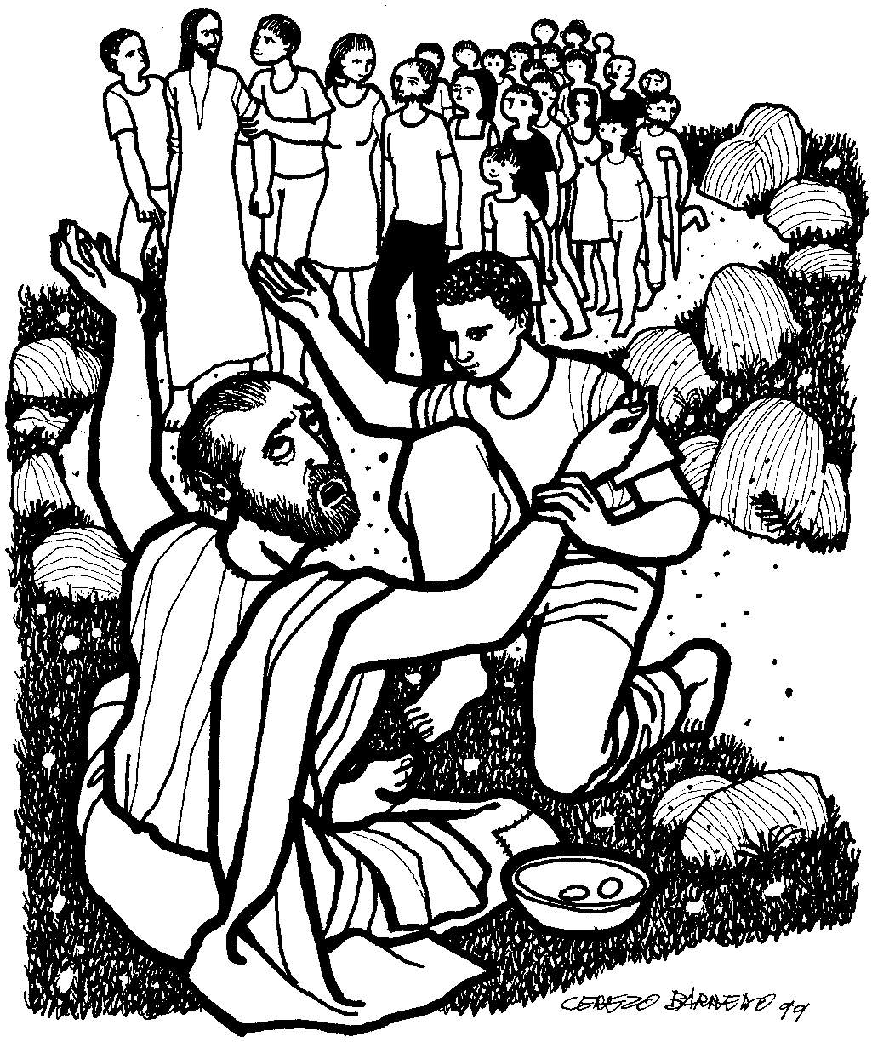

**October 27th, 2024**

**10:30 am Worship**

*\*Please rise if you are able at these points in the service*

**Gathering Music**

**Welcome, Church Announcements and Special Concerns**

**Prelude and Time of Quiet Reflection**

**\*Call to Worship**

L: Come, take refuge in the Lord, for God is good.  
**P: From the storms and struggles of life we come.**L: Come, rejoice in the Lord, for God will provide peace for you.  
**P: From fear and anxiety, we come to find peace.**L: Come, open your hearts to the Lord and you will be given blessing.  
**P: Thanks be to God for the many ways in which we are blessed. AMEN.**

**\*Hymn** "O For a Thousand Tongues to Sing" **No. 5**

**Opening Prayer** (*Unison*)

**Open our eyes, Lord. Help us to see Jesus as he reaches out to heal our blindness. Help us to let go of all those things that keep us in darkness. This day, as your word is proclaimed, let our hearts and souls respond with joy. Transform our lives to do your will. In Jesus’ Name, we pray. AMEN.**

**Scripture Reading**  Mark 10:46-52

**Hymn** “Spirit of the Living God” *Twice*  **No. 259**

**Message**

**Hymn** “Amazing Grace" **No. 546**

**Prayers of the People**

**Silent Prayer**

**Pastoral Prayer and The Lord's Prayer**

**Our Father, who art in heaven, hallowed be Thy Name. Thy kingdom come, thy will be done on earth as it is in heaven. Give us this day our**

**daily bread. And forgive us our sins, as we forgive those who sin**

**against us. And lead us not into temptation, but deliver us from evil.**

**For thine is the kingdom and the power, and the glory, forever and ever. Amen.**

**Offering Invitation**

**\*Response No.46**

**Praise God from whom all blessings flow; praise God, all creatures here below; praise God above, ye heavenly host: Praise God, the Son, and Holy Ghost. Amen.**

**\*Prayer of Dedication** (*Unison*)   
**Bless these gifts by the power of your Spirit, O God. May someone near or far receive grace and hope for living because**

**of what we share here today. Amen.**

**\*Hymn** “Open My Eyes, That I May See” **No. 586**

**\*Benediction**

Darkness has been banished. Sight has been restored. Your lives are reformed in Christ’s love. Go now in peace to serve with great joy. Bring the love of God with you so that the light which has brightened your life may shine for others. Go no, beloved, to serve. **AMEN.**

**\*Closing**  "Go in Peace"

**Go in peace and the peace of God be with you this day,**

**Go in peace and the peace of God be with you always.**

**Celebrate and share the joy, Celebrate new life,**

**Go in peace and the peace of God be with you always.**

**\*Postlude**

**Our Church Gifts:**

**_____________________________________________________**

**_____________________________________________________**

**_____________________________________________________**

**_____________________________________________________**

**_____________________________________________________**

**_____________________________________________________**

**_____________________________________________________**

**_____________________________________________________**

**_____________________________________________________**

**_____________________________________________________**

**_____________________________________________________**

**_____________________________________________________**

**_____________________________________________________**

**_____________________________________________________**

**_____________________________________________________**

**_____________________________________________________**

**_____________________________________________________**

**_____________________________________________________**

**_____________________________________________________**

**_____________________________________________________**

**Our Church Gifts:**

**_____________________________________________________**

**_____________________________________________________**

**_____________________________________________________**

**_____________________________________________________**

**_____________________________________________________**

**_____________________________________________________**

**_____________________________________________________**

**_____________________________________________________**

**_____________________________________________________**

**_____________________________________________________**

**_____________________________________________________**

**_____________________________________________________**

**_____________________________________________________**

**_____________________________________________________**

**_____________________________________________________**

**_____________________________________________________**

**_____________________________________________________**

**_____________________________________________________**

**_____________________________________________________**

**_____________________________________________________**