Announcements
On our calendar – April 14th: Food Pantry Sunday
April 21: Quarterly meeting after worship
April 28th: Deacon’s Meeting @9:30
May 5th: Pastor Joel Off, no streaming available
April Birthdays: Greg Held – April 8, Greg Thompson – April 15, Phil Solyntjes – April 22, Steve Degner – April 23,

In our prayers: Margie, Tammy, Lee, Glen, Therese Canfield, Toni, Betty, the people of Ukraine, Bruce, Mary’s neighbors, Kathy’s Mom, Becca Oden, Tracey Peterson, Stacy Hall, Vicky, Judy, Philip, Mary’s sister Diane as she begins her cancer treatment, Kip, Barb’s friends Rita and Chuck, the Aderman Family, Charlotte’s newest great grandbaby, Barb’s friend’s grandson Noah, the Ray Family, Kris Albert, the people of Israel, Gaza, and all innocent lives caught in the line of fire, Bonnie, those battling cancer, the Ray family, Janice, Elliot Degner, Kathy’s mother and family, Doug, Lisa, Lee White,

Pastor Joel Zimmerman can be reached at 715-256-7808 and pastorjzimmerman@gmail.com.

2nd Sunday of each month is Food Pantry Sunday, please bring your non perishable food donations!

Prayer of the Week:
Thank you for the gift of life, health, and strength. Thank you for your provision and protection. Lord, I ask that you guide me through this week and help me to be successful in all that I do. Grant me the wisdom to make good decisions, the strength to overcome challenges, and the courage to step out in faith. Amen.

Namekagon Congregational Church, UCC
W4446 Friday Street
Earl, WI 54875 • 715-635-2903
www.earlucc.com

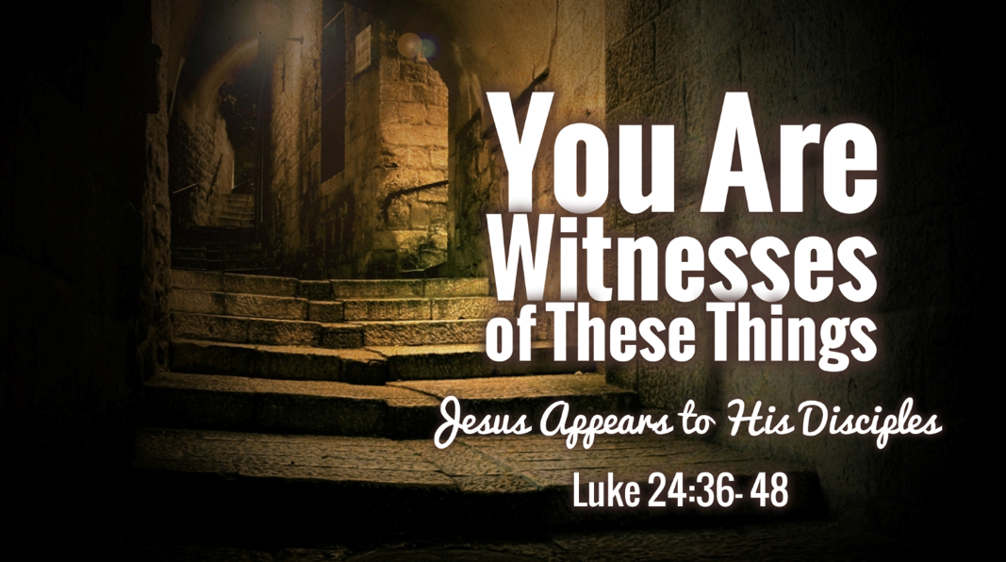

April 14, 2024
10:30 am Worship

*Please rise if you are able at these points in the service

Gathering Music

Welcome, Church Announcements and Special Concerns
Prelude and Time of Quiet Reflection

*Call to Worship
L: We are called to be God’s children.
P: God’s love has been poured on us through Jesus Christ!
L: Fear and doubt are gone!
P: Joy and Celebration ring in our hearts!
L: Come, let us raise our voices in song!
P: Let us offer our hearts and souls to God in prayer and praise. AMEN.

*Hymn "Now the Green Blade Rises" No. 230

Opening Prayer (Unison)
Lord of Light and Mercy, be with us this day as we again hear the stories of faith and sight. Help us to believe in your abiding presence with us, both in our darkness and in the light which you bring. Give us courage and strength to witness to your resurrection. For we offer this in Jesus’ Name, AMEN.
Scripture Reading Luke 24:36b-48

Hymn “Spirit of the Living God” Twice No. 259

Message

*Hymn “Because He Lives” No. 562

Prayers of the People
Silent Prayer
Pastoral Prayer and The Lord's Prayer

Our Father, who art in heaven, hallowed be Thy Name. Thy kingdom come, thy will be done on earth as it is in heaven. Give us this day our
daily bread. And forgive us our sins, as we forgive those who sin
against us. And lead us not into temptation, but deliver us from evil.
For thine is the kingdom and the power, and the glory, forever and ever. Amen.

Offering Invitation

*Response No.46
Praise God from whom all blessings flow; praise God, all creatures here below; praise God above, ye heavenly host: Praise God, the Son, and Holy Ghost. Amen.

*Prayer of Dedication (Unison)
Bless these gifts by the power of your Spirit, O God. May someone near or far receive grace and hope for living because
of what we share here today. Amen.

*Hymn "I Love To Tell The Story” No. 480

*Benediction
Go in courage and peace, proclaiming the Risen Lord to all! Be those who bring hope and justice to a hungry and hurting world! The peace of the Lord is with you now and forever. AMEN.

*Closing "Go in Peace"
Go in peace and the peace of God be with you this day,
Go in peace and the peace of God be with you always.
Celebrate and share the joy, Celebrate new life,
Go in peace and the peace of God be with you always.
*Postlude

