Announcements
On our calendar – April 2: Palm Sunday
April 5: Ladies Aid at Noon
April 7: Good Friday Service @ 2pm
Aptil 9: Easter Sunday

March Birthdays: Mary Nowaczyk – March 1; Sharon White – March 15; Margie Ruid – March 25;

In our prayers: Margie, Sylas, Tammy, Lee, Glen, Larry Meier, Therese Canfield, Toni, Betty, the people of Ukraine. Women in this nation. Bruce, Jolene, Earthquake victims in Turkey. The people of East Palestine. Rob Mackie and family and friends of Tom Mackie, Bonnie Meier, Betty Pinkston, Mary’s neighbors.

Pastor Joel Zimmerman can be reached at 715-256-7808 and pastorjzimmerman@gmail.com.

2nd Sunday of each month is Food Pantry Sunday, please bring your non perishable food donations!

Namekagon Congregational Church, UCC
W4446 Friday Street
Earl, WI 54875 • 715-635-2903
www.earlucc.com

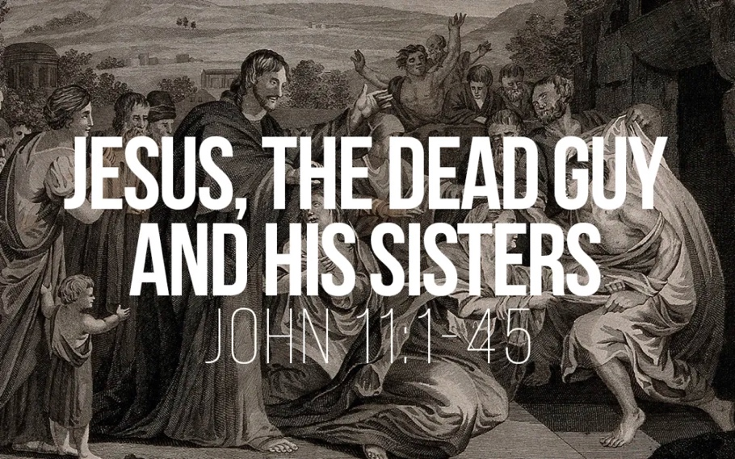

March 26, 2023
10:30 am Worship

*Please rise if you are able at these points in the service

Gathering Music

Welcome, Church Announcements and Special Concerns
Prelude and Time of Quiet Reflection

*Call to Worship
L: Lazarus, though dead, was called to life by Jesus.
P: May we be called to the light of righteousness.
L: As others witnessed this resurrection, they believed in Jesus.
P: May we, who have heard, believe in the power of Jesus to conquer our fears and doubts.
L: Praise be to God who has given us Jesus.
P: Praise be to Jesus who has given us life. AMEN.

*Hymn "How Firm a Foundation" No. 618

Opening Prayer (Unison)
Healing and Empowering God, we are sometimes so sure that things will not work out, we doubt even your ability to put things right in our lives. We lack such faith. But Jesus came to show us that our most dreaded enemy--death--can be overcome by faith. Heal our doubts and our longings for assurance and give us spirits of trust and hope. In Jesus’ Name, we pray. AMEN.

Scripture Reading John 11:1-45

Hymn “Spirit of the Living God” Twice No. 259

Message

*Hymn “There is a Balm in Gilead” No. 501

Prayers of the People
Silent Prayer
Pastoral Prayer and The Lord's Prayer
Our Father, who art in heaven, hallowed be Thy Name. Thy kingdom come, thy will be done on earth as it is in heaven. Give us this day our
daily bread. And forgive us our sins, as we forgive those who sin
against us. And lead us not into temptation, but deliver us from evil.
For thine is the kingdom and the power, and the glory, forever and ever. Amen.

Offering Invitation

*Response No.46
Praise God from whom all blessings flow; praise God, all creatures here below; praise God above, ye heavenly host: Praise God, the Son, and Holy Ghost. Amen.

*Prayer of Dedication (Unison)
Bless these gifts by the power of your Spirit, O God. May someone near or far receive grace and hope for living because
of what we share here today. Amen.

*Hymn "Softly and Tenderly” No. 340

*Benediction
Lord, unbind us from our fears and doubts. As we go from this place of worship, be with us in our witness to the power and love of Jesus Christ. AMEN.

*Closing "Go in Peace"
Go in peace and the peace of God be with you this day,
Go in peace and the peace of God be with you always.
Celebrate and share the joy, Celebrate new life,
Go in peace and the peace of God be with you always.
*Postlude

