Announcements
On our calendar –
January 23rd – All Church Meeting after worship

January Birthdays: John Canfield, January 7th, Dorothy Norstrom- January 8th, Matthew Ray– January 13th, Dakota Mork – January 25th

Pastor Joel Zimmerman can be reached at 715-256-7808 and pastorjzimmerman@gmail.com.

In our prayers: Margie, Sylas, Scott and Sue, Linda Degner, Tammy, Lee, Kathleen Helm and Family, Bryn, Jean, Ross Benavides, Larry Meier, Greg Odden’s Family, Bruce Nowaczyk, Carol Buckman, Lorraine Thompson, Joe and Rachel Vanda, Therese Canfield, those suffering physically and/or mentally from the continued pandemic

2nd Sunday of each month is Food Pantry Sunday, please bring your non perishable food donations!

We are on Facebook! Follow us @NamekagonUCC

Namekagon Congregational Church, UCC
W4446 Friday Street
Earl, WI 54875 • 715-635-2903
www.earlucc.com

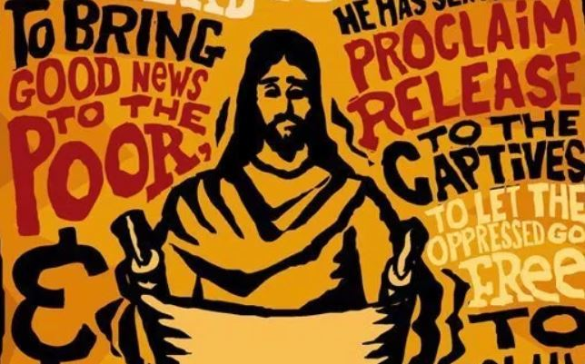

January 23, 2022
10:30 am Worship

*Please rise if you are able at these points in the service

Ringing of the Bells and Gathering Music

Welcome, Church Announcements and Special Concerns
Prelude and Time of Quiet Reflection
*Call to Worship
L: God's glory is pouring forth from the heavens.
P: Earth below receives the good news with great joy.
L: The promise is sure and true, that Jesus has come to show us the best ways to serve God.
P: By serving and caring for others, we truly serve God.
L: Come, let us prepare ourselves for joyful service.
P: Lord, make us ready for great service in your name. AMEN.

*Hymn "Christ is Made the Sure Foundation" No. 275

Opening Prayer (Unison)
Leading and Guiding God, you have opened the doors to us for true service. We are encouraged to become involved in ministries of peace and justice. The light of promise is reflected in your Spirit which rests in each one of us. Get us ready to serve you. Guide our lives, as we learn more of what you would have us do. AMEN.

Scripture Reading Luke 4:14-21

*Hymn “Spirit of the Living God” Twice No. 259

Message

Hymn “Open My Eyes" No. 586

Prayers of the People
Silent Prayer
Pastoral Prayer and The Lord's Prayer
Our Father, who art in heaven, hallowed be Thy Name. Thy kingdom come, thy will be done on earth as it is in heaven. Give us this day our
daily bread. And forgive us our sins, as we forgive those who sin
against us. And lead us not into temptation, but deliver us from evil.
For thine is the kingdom and the power, and the glory, forever and ever. Amen.

Offering Invitation

*Response
We give thee but thine own, whate’er the gift may be
All that we have is thine alone, a trust, O Lord, from thee.

*Prayer of Dedication (Unison)
With gratitude for all the blessings you have poured into our lives, Lord Jesus, we come bringing these our gifts that they may be used in service to those in need. Bless these gifts and those who have given them, that they may truly be a blessing in your holy name. AMEN.

*Hymn “O For a Thousand Tongues To Sing” No. 5

*Benediction
The promise has been given. We have been called to ministries of service. God goes with us in all that we do, enabling and encouraging us as we serve others. Go in peace. AMEN.

*Closing "Go in Peace"
Go in peace and the peace of God be with you this day,
Go in peace and the peace of God be with you always.
Celebrate and share the joy, Celebrate new life,
Go in peace and the peace of God be with you always.
*Postlude

