Announcements
On our calendar – April 21: Quarterly meeting after worship
April 28th: Deacon’s Meeting @9:30
May 5th: Pastor Joel Off, no streaming available
June 2nd: Pastor Joel Off, no streaming available
April Birthdays: Greg Held – April 8, Greg Thompson – April 15, Phil Solyntjes – April 22, Steve Degner – April 23,

In our prayers: Margie, Tammy, Lee, Glen, Therese Canfield, Toni, Betty, the people of Ukraine, Bruce, Mary’s neighbors, Kathy’s Mom, Becca Oden, Tracey Peterson, Stacy Hall, Vicky, Judy, Philip, Mary’s sister Diane as she begins her cancer treatment, Kip, Barb’s friends Rita and Chuck, the Aderman Family, Charlotte’s newest great grandbaby, Barb’s friend’s grandson Noah, the Ray Family, Kris Albert, the people of Israel, Gaza, and all innocent lives caught in the line of fire, Bonnie, those battling cancer, the Ray family, Janice, Elliot Degner, Kathy’s mother and family, Doug, Lisa, Lee White,

Pastor Joel Zimmerman can be reached at 715-256-7808 and pastorjzimmerman@gmail.com.

2nd Sunday of each month is Food Pantry Sunday, please bring your non perishable food donations!

Prayer of the Week:
We thank you, creator God,
for the goodly heritage you offer us,
from green downland
to the deep salt seas,
and for the abundant world
we share with your creation.
Keep us so mindful of its needs
and those of all with whom we share,
that open to your Spirit
we may discern and practice
all that makes for its wellbeing,
through Jesus Christ our Lord, Amen.
Namekagon Congregational Church, UCC
W4446 Friday Street
Earl, WI 54875 • 715-635-2903
www.earlucc.com

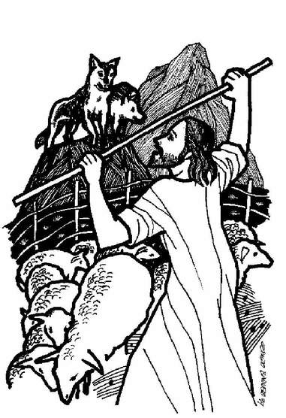

April 21, 2024
10:30 am Worship

*Please rise if you are able at these points in the service
Gathering Music

Welcome, Church Announcements and Special Concerns
Prelude and Time of Quiet Reflection

*Call to Worship
L: Come, walk with the Lord this day.
P: We seek places of peace and rest from the stresses of our lives.
L: The Shepherd will lead you to places where your soul may be restored.
P: We come, sometimes fearful of the hostilities of the world.
L: In the midst of all the turmoil, The Shepherd will provide for your needs abundantly.
P: Surely these wonders will heal and restore our spirits. AMEN.

*Hymn "Christ Is Made the Sure Foundation" No. 275

Opening Prayer (Unison)
O God, we thank you for this earth, our home; For the wide sky and the blessed sun, For the salt sea and the running water, For the everlasting hills And the never-resting winds, For trees and the common grass underfoot. We thank you for our senses By which we hear the songs of birds, And see the splendor of the summer fields, And taste of the autumn fruits, And rejoice in the feel of the snow, And smell the breath of the spring. Grant us a heart wide open to all this beauty; And save our souls from being so blind That we pass unseeing When even the common thorn bush Is aflame with your glory, O God our creator, Who lives and reigns forever and ever. Amen.

Scripture Reading Acts 4:5-12, John 10:11-18

Hymn “Spirit of the Living God” Twice No. 259

Message
*Hymn “He Leadeth Me: O Blessed Thought” No. 545

Prayers of the People
Silent Prayer
Pastoral Prayer and The Lord's Prayer

Our Father, who art in heaven, hallowed be Thy Name. Thy kingdom come, thy will be done on earth as it is in heaven. Give us this day our
daily bread. And forgive us our sins, as we forgive those who sin
against us. And lead us not into temptation, but deliver us from evil.
For thine is the kingdom and the power, and the glory, forever and ever. Amen.

Offering Invitation

*Response No.46
Praise God from whom all blessings flow; praise God, all creatures here below; praise God above, ye heavenly host: Praise God, the Son, and Holy Ghost. Amen.

*Prayer of Dedication (Unison)
Bless these gifts by the power of your Spirit, O God. May someone near or far receive grace and hope for living because
of what we share here today. Amen.

*Hymn "Savior, Like a Shepherd Lead Us” No. 558

*Benediction
The Good Shepherd leads us forward, from this place, into the world to serve God’s people, to witness to God’s love in all that we do. Go in peace and God’s peace will go with you. AMEN.

*Closing "Go in Peace"
Go in peace and the peace of God be with you this day,
Go in peace and the peace of God be with you always.
Celebrate and share the joy, Celebrate new life,
Go in peace and the peace of God be with you always.
*Postlude

